***DCL and TCL***

1. WE HAVE TO CREATE THE TABLE BOOK
2. USE SAVE POINT AND USE ROOLBACK
3. THEN USE TO INSERT THE VALUES INTO THE TABLE
4. 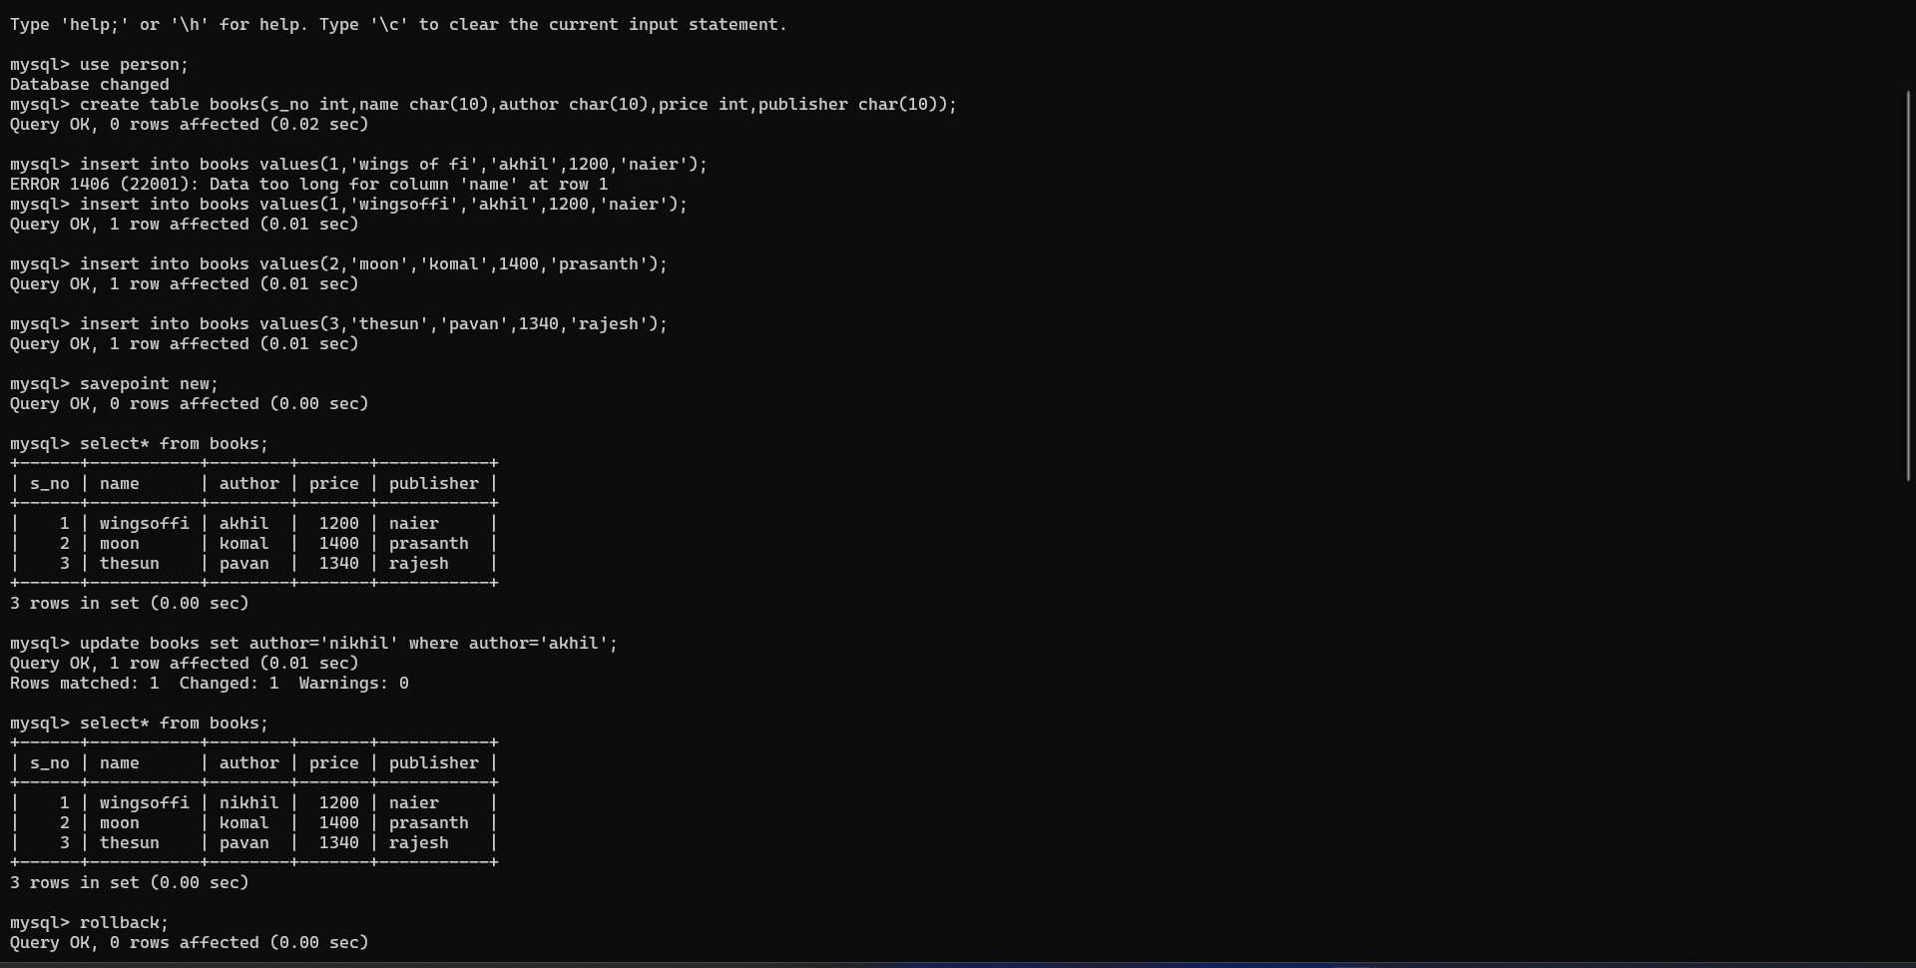USE THE GRANT AND REVOKE